**TC1018 – Data Structures**

**Fall 2018**

**Final exam – 120 minutes**

Instructions: Answer the questions below. You can use one sheet of notes

Name: _____________________________________________________________

1. **[10 points]** Find the best answer to the following multiple choice questions
   1. What is the main characteristic of a stable sorting algorithm?
      1. The complexity is O(log n) consistently
      2. Elements with the same value appear in the output array in the same order as they do in the input
      3. Complexity is the same regardless of the input
      4. The sorting is done in place with O(n)
   2. The runtime of an algorithm depends on
      1. Data size
      2. Processor speed
      3. Language
      4. RAM
      5. All of the above
      6. None of the above
   3. Inserting an element to the beginning of an array (that is A[0] element) is more difficult than inserting an element to the beginning of a linked list.
      1. TRUE
      2. FALSE
   4. What is the best data structure to solve the following problem? A list needs to be built dynamically. Data must be easy to find, preferably in O(1). The user does not care about any order statistics such as finding max or min or median.
      1. Use an Array
      2. Use a Singly LL
      3. Use a Stack
      4. Use a Queue
      5. None of the above
   5. Consider a sorted circular doubly-linked list where the head element points to the smallest element in the list. What is the asymptotic complexity of finding the smallest element in the list?
      1. O(1)
      2. O(n)
      3. O(log n)
      4. None of the above
   6. Which of the following is not a stable sorting algorithm in its typical implementation.
      1. Insertion sort
      2. Merge sort
      3. Quick sort
      4. Buble sort
   7. What type of graph is used in Twitter?
      1. Directed graph
      2. Undirected graph
      3. Partially connected graph
      4. Tree
2. **[10 points]** Complete the following method in the LinkedList class. The method contains is supposed to return true if the there is a node in the list that is equal to the given Comparable c. You can assume the Node class has the public fields, data (a Comparable) and next (a pointer to another Node).   
   1. public boolean contains(Comparable c) {

1. **[10 pts]** Using a regular queue implement a Stack

1. **[10 pts]** Implement the algorithm for the suggestion box in WhatsApp. Given a letter, you should suggest a word for the user, e.g. the user types “A”, which will be the input to the function, and the output should be a suggestion of TWO words starting with “A”. Specify what data structure you are using and why.
2. **[10 pts]** The adjacency list representation of a graph with five vertices A, B, C, D, E is given below

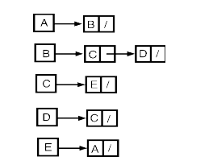

* 1. Draw the adjacency matrix

1. Draw the graph
2. **[10 pts]** Consider a singly linked list of nodes and the following method is called on the head node of the list:

void mystery(Node node) {

if(node == null) return;

mystery(node.getNext());

System.out.println(node.getData());

}   
  
The given linked list is shown below. What will the above program print?



1. **[10 pts]** Consider the following directed graph

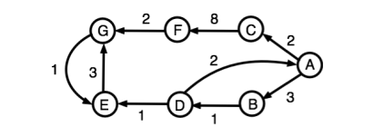

Considering the nodes are visited in alphabetical order, write down the order in which the vertices will be visited by a BFS and DFS

DFS:

BFS:

1. **[10 pts]** In the graph below, user Dijkstra’s shortest path algorithm to compute the shortest path from vertex A to all other vertices. Write down the steps and the inputs in the

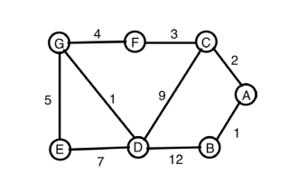

1. Starting from vertex A, write down the order in which the vertices will be added by Dijkstra’s shortest path algorithm while computing the shortest paths.
2. **[10 pts]** Suppose you were asked to write a method that will take two sorted stacks A and B (min on top) and create one stack that is sorted (min on top). You are allowed to use only the stack operations such as pop, push, size and top. No other data structure such as arrays are not allowed. You are allowed to use as many stacks as needed (HINT: 3 are enough). Note that elements on the stack can be compared using compareTo.